Backing up and Restoring a Virtual Machine
Problem Statement: Backing up and restoring a virtual machine
Step 1: Go to the virtual machine, which you want to backup. Click on ‘Backup’ in theleft-side menu bar under ‘Operations’
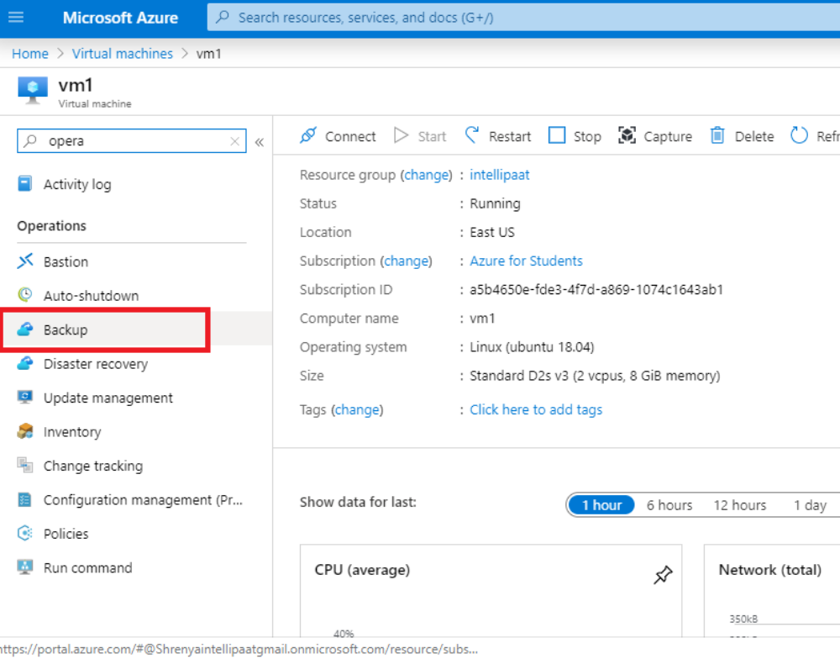

Step 2: It will take you to an Azure backup wizard. Fill in the details such as the vault name and the backup policy
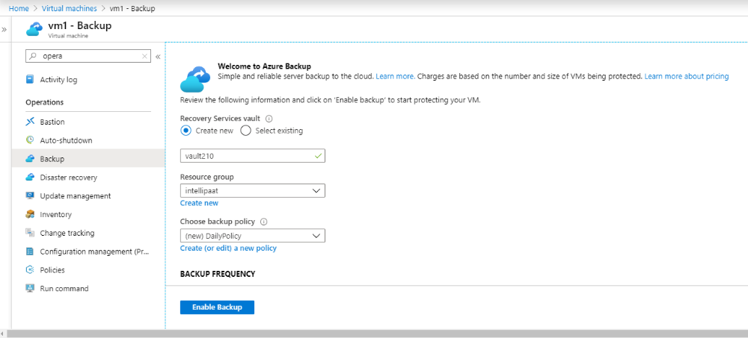
Step 3: Once the deployment is complete, go to the vault that has been created
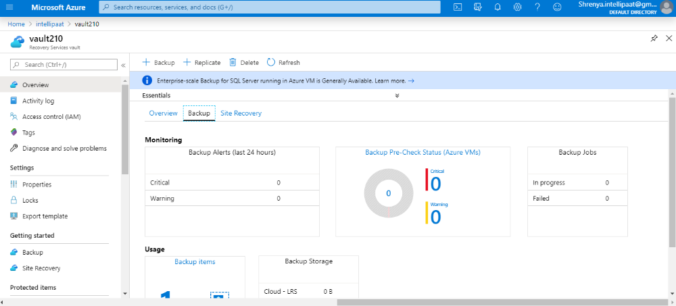
Step 4: Your backup has now been configured. Go to ‘Backup items’ inside the vault and select ‘Azure Virtual Machine’
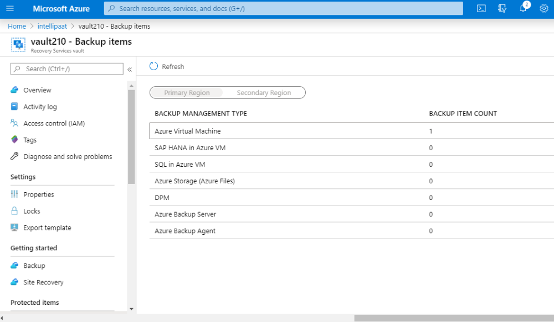
Step 5: It will show a list of all the backups that have taken place till date. Select the backup from where you want to restore your virtual machine
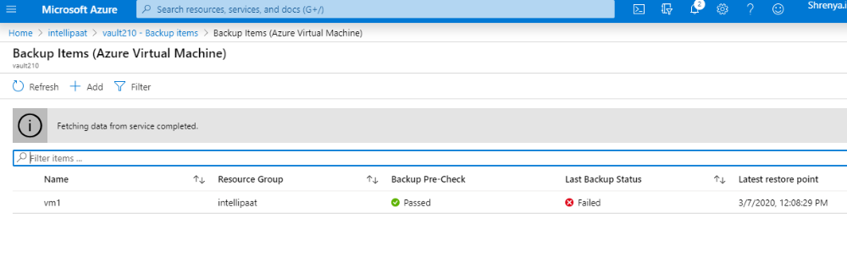
Step 6: Now, click on ‘Restore VM’ from the top menu bar
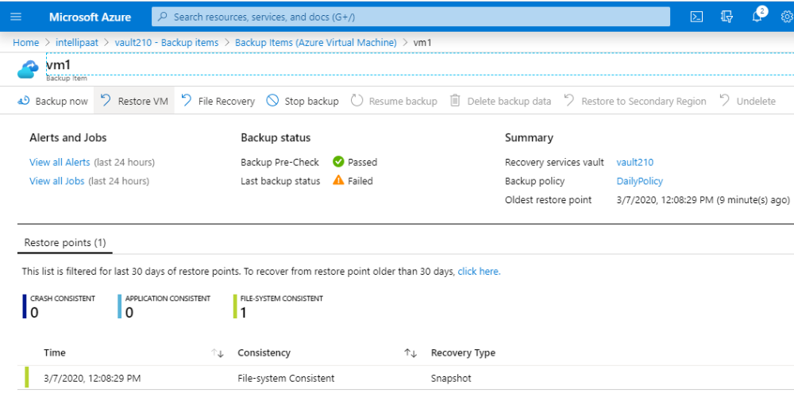
Step 7: It will take you to a 2-step restore wizard. In Step 1, select the point from where you want to restore your machine and click on ‘OK.’ In Step 2, set your restoring configuration settings
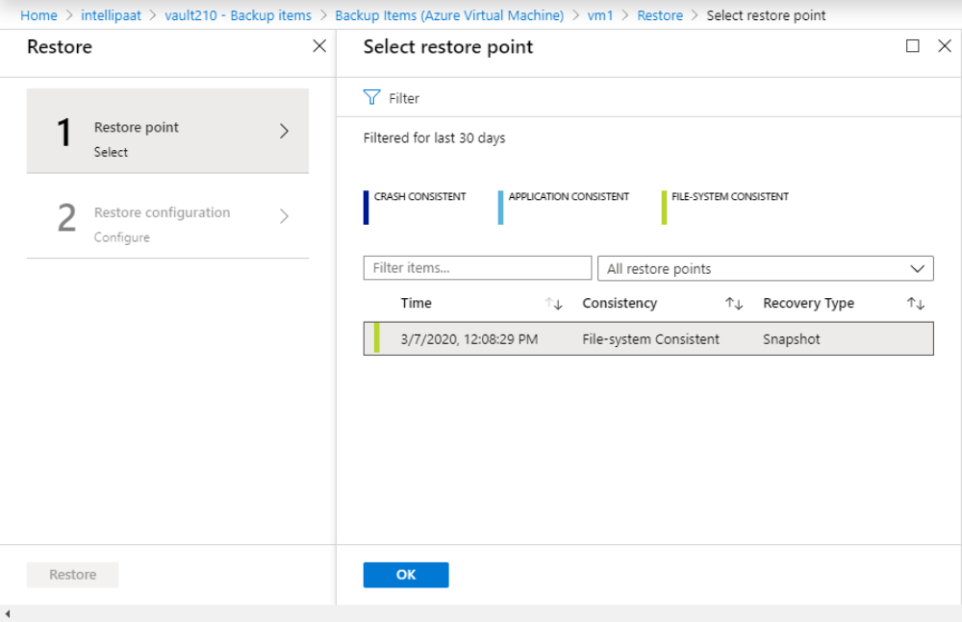
Step 8: Once you’re done setting up both, click on ‘Restore’
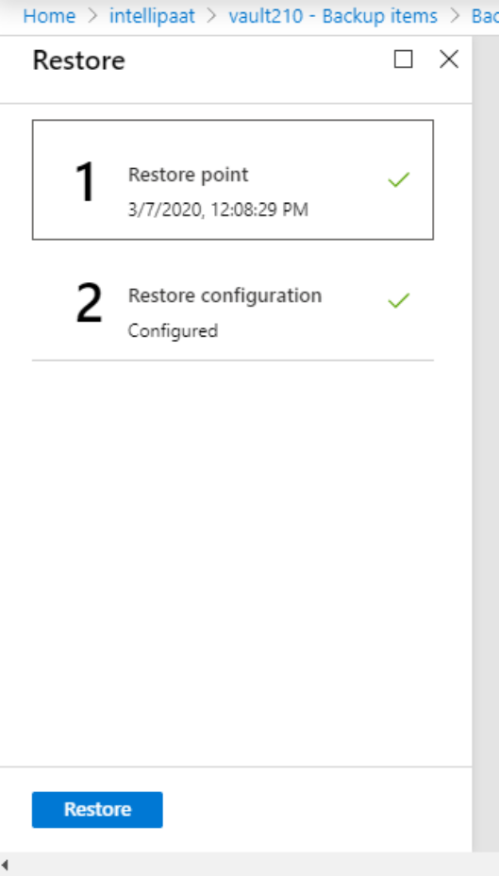
Step 9: Once the resource has been deployed, go to ‘Virtual machines’ on Azure Portal. You will see that your virtual machine has been deployed under the source as ‘Disk’
